**Exercise - Create your first topic**

In this exercise, you'll create your first topic. This topic is basic for creating a simple experience and then testing and publishing to a demo website. The **Publish demo** exercise in this module goes into more detail on the authoring capabilities that are available for you to expand and build on the topic that you create in this exercise.

**Section 1: Create a new topic manually**

In this first task, you manually create a new topic by following these steps:

1. Select **Topics** from the top menu within your recently created copilot.
2. From the **+ Add a topic** drop down at the top of the screen, select **Topic** and then the **From blank** option.
3. Select **Edit** on the **Phrases** section of the trigger and then enter the following phrases: order status, track my order, where is my package, check order status, has my order shipped. These phrases are added on the right side panel (as shown in the following screenshot). The phrases are also visible in the Trigger Phrases node.

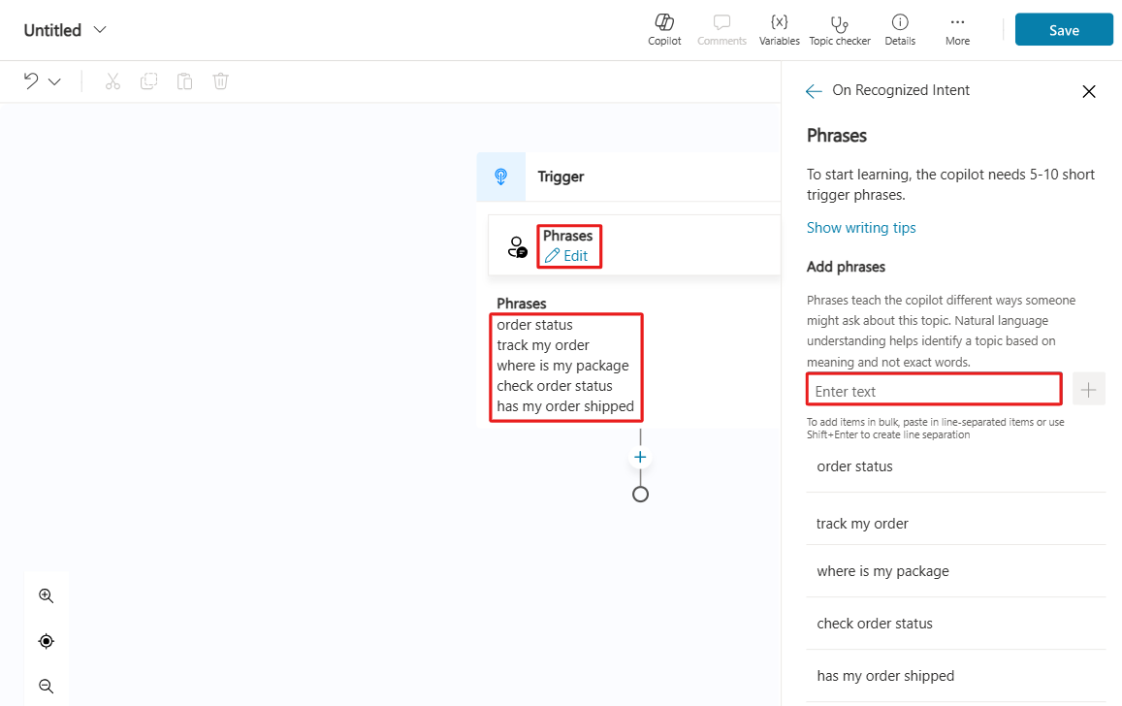

1. Select the **Details** button within the top right corner to open the **Topic Details** pane. Rename your topic to Check Order Status, and then select **Save**.

**Section 2: Review the topic UI**

Now that you created your first topic, albeit without content except trigger phrases, you can explore the authoring user interface (UI) to become more familiar with it.

**A. Topic title**

* The name of the topic that you're currently creating, which is visible on the **Topics** page.

**B. Productivity bar**

* Where you have access to productivity tools, such as copy and paste, which is available in Preview.

**C. Authoring canvas controls**

* You can use these controls to navigate the authoring canvas, which can become large for extensive topics. The included controls are zoom, grab, and selection.

**D. Nodes**

* This section shows nodes, which are referred to as the items within an authoring canvas in Microsoft Copilot Studio. Often, nodes have a type that drives what options are available and required. Examples include the message node, question node, or topic node.

**E. Copilot, Comments, Variables, Topic checker, Details, Analytics, and Code Editor**

* This area includes **Copilot**, which enables you to utilize Microsoft Copilot to help build your copilots, and **Comments** where you can collaborate with multiple users or take notes on the copilot's production. The **Variables** tab helps you keep track of all known variables used in your topic. **Topic checker** is a debugging tool you can run to test if your topic has any bugs or errors. **Details** allows you to edit the name, description, and status of your topic, and create or observe the input and output variables of the selected topic. Under the **More** tab, you can find the **Analytics** section that displays the statistics on engagement with your copilot, and the **code editor**, where you can interact with your topic in a lower-level language as opposed to the graphical interface.

**F. Authoring canvas**

* The area where you'd create your topic. This area is referred to as a canvas due to the empty space that it gives you to build and connect nodes. It might look empty to begin with, but when you start adding nodes, such as conditions, the canvas fills up quickly.

**Section 3: Add content to your topic**

This exercise doesn't cover how to add a large amount of content to your topic; rather, it provides the steps to add a single question node, message node, and topic redirection so that you can become familiar with the overall process of creating a topic, testing, and publishing in Microsoft Copilot Studio. The **Publish demo** exercise in this module covers a more in-depth review of the authoring capabilities in Microsoft Copilot Studio.

The next section of this exercise covers foundational knowledge for understanding the central components of Microsoft Copilot Studio and creating topics.

**Section 4: Question nodes**

As a copilot author, you should use the **Question** node when you're expecting a response from the user and you want to do something based on that information. The user response is stored in a variable, and question nodes can also use entities and slot filling features, both concepts that are covered later in this exercise.

The **Question** node uses many functions that a Message node does, such as rich text, speech authoring, and rich text response types such images, videos, and adaptive cards.

1. In the topic that you have open from the previous task, select the **Add node** button below the existing node in the canvas and then select **Ask a question** to add a new Question node.
2. Enter What would you like to do with your order? in the field and then make sure that the **Identify** value is set to **User's entire response**. This node is asking the question after the topic is triggered about what the user wants to do. The **Publish demo** exercise extends this task to use entities and slot filling.  
   A screenshot of a chat

   Description automatically generated

**Section 5: Message nodes**

You can use the **Message** node to display a message to the user. This message can be simple based on the topic of the conversation. In direct contrast to the Question node, the Message node doesn't expect or store an answer from the user. The Message node has rich text options that you can display in text. You can also use variables within message nodes in the body of text displayed to the user, which is dynamic based on the data stored within them. This capability allows messages to be more personal, such as *Hello {name}, I can get those order details for you, one moment*. Variables can also store data to perform automation or calculations on them. Later exercises cover variables more in depth.

1. To add another node, select the **+** button below the Question node. Then, select **Send a message**. Enter a message that acknowledges the customer's question, such as Thank you for your question!.

1. End the conversation for the customer in this demo scenario. Select the **Add node** button below the message node within the authoring canvas. Hover over the **Topic Management** option, and then select **End conversation** to end the conversation.

1. Then, within the top right hand corner of the screen, select the **Save** button.

Other ways to end a conversation exist, such as directing to a feedback topic or transferring the conversation, but they aren't covered in this exercise.

**Section 6: Use Copilot in Microsoft Copilot Studio to create a topic**

Creating topics in Microsoft Copilot Studio is more effortless than before. Now, you can create a topic in Microsoft Copilot Studio by using natural language to describe what you want the topic to do. With the **Create from description with Copilot** feature, you can automatically build a topic, reducing some manual steps that you experienced from the first task in this unit. In this task, you'll learn how simple and quick creating a topic with **Copilot** can be.

1. Select **Topics** from the navigation pane at the top of the Copilot screen.
2. Select the **+ Add a topic** drop down, and choose **Create from description with Copilot**. A new window appears, asking you to **Name your topic** and enter a description in the **Create a topic to** space.

1. Enter Order Status in the **Name your topic** field.
2. In the **Create a topic to** space, enter Create a topic that provides the status of an order for a customer, asking them their name, order number, and when it was ordered.
3. Select **Create**.

Copilot creates your topic, including the trigger phrases, question nodes, entity selection, variable naming, and message node confirmation.

1. Select the **Copilot** button in the upper part of the authoring canvas (if the **Edit with Copilot** panel isn't open already).
2. Within the **Edit with Copilot** panel, in the field **What do you want to do?**, enter Add a question to ask the user to choose their preferred contact method, choosing from email, phone, or SMS. Then, select **Update**.

Copilot automatically adds a question node, which both asks the customer for their contact method, and stores their choice in a variable.

The Copilot feature in Microsoft Copilot Studio drastically reduces authoring time, allowing you to create and edit topics by using natural language. Additionally, the **Edit with Copilot** panel shows what updates have been created, and it provides suggestions for what you can update in your topic.

To complete the exercise, exit the topic without saving. If you accidentally saved the topic, turn off the topic by switching the **Status** toggle to **Off**, as shown in the following screenshot. A screenshot of a computer

**Section 7: Test your copilot**

Now, you will test the **Check Order Status** topic that you created in the first task.

1. Select the **Test** button in the top right corner of the screen to open the testing panel.

1. The **Conversation Start** message appears, and your copilot starts a conversation. In response, enter a trigger phrase for the **Check Order Status** topic that you previously created in the exercise. Remember, after turning off the **Order Status** topic, it won't be available in the **Test Copilot** area.

**Note**

If you previously had a conversation open in the test pane, you will need to select the circle icon at the top of the chat window to refresh the chat and start a new conversation.

Your message appears, and your copilot responds as instructed by the topic designed in the previous steps. Now, the topic is working as it should, and it's time to publish your copilot.